

ONLINE EXAM SYSTEM



August 12, 2020

Volkswagen AG

[Company address]

**Online Exam System:**

In this I have designed registration page for admin and student .Admin have all the access, Admin can add delete and update the student details. Whereas student can only give the exam and see the result right after they submit the test.

**Flow chart:**

DELETE QUESTION

INVALID CREDENTIAL

INVALID CREDENTIAL

TRY AGAIN

UPDATE QUESTION

EXAM

LOGOUT

LOGOUT

RESULT

UPDATE DETAIL

LOGIN

LOGIN

TEACHER/ADMIN

STUDENT

REGISTRATION FORM

**START**

1. REGISTRATION FORM::

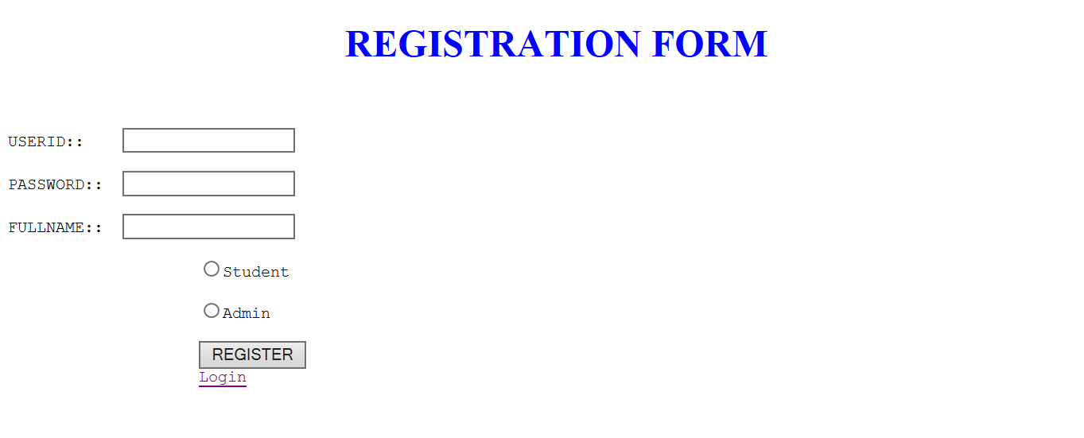

In this we have enter the name ,userid and password.After entering we have to choose if student then select student .If teacher/admin then select Admin and hit on register button.

If account already exist click on login.

1. Login page::

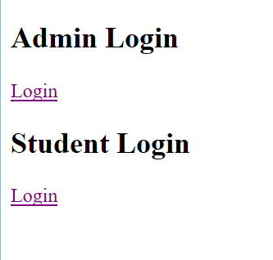

If admin click on admin login or else student login

1. Admin login and Student login::

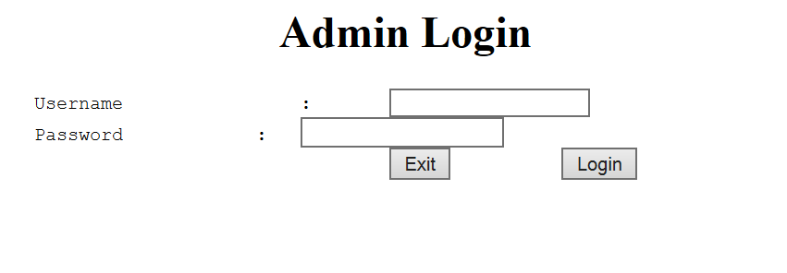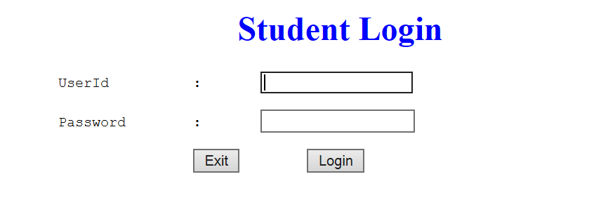

Here we have right the credential for student and admin .If its right then we can go for next page.

1. Admin login::



*After entering the right credential Admin can access the student details .Admin can add update as well as Add and Update the Question.

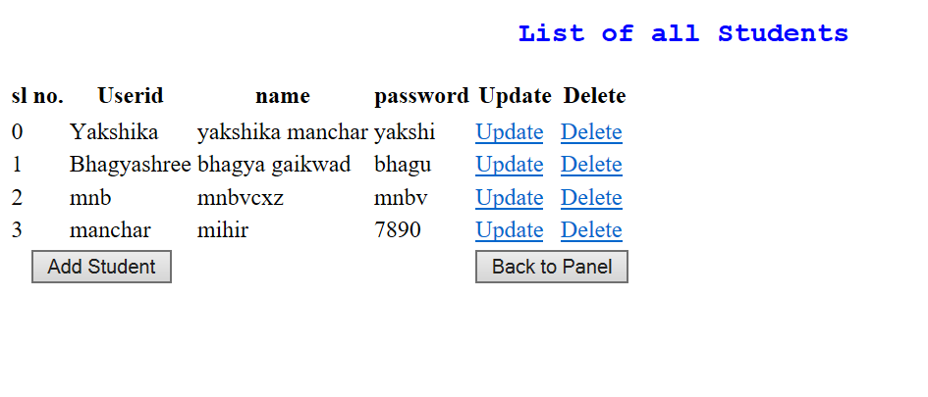

In this Admin can see and change And can delete the details of the student.

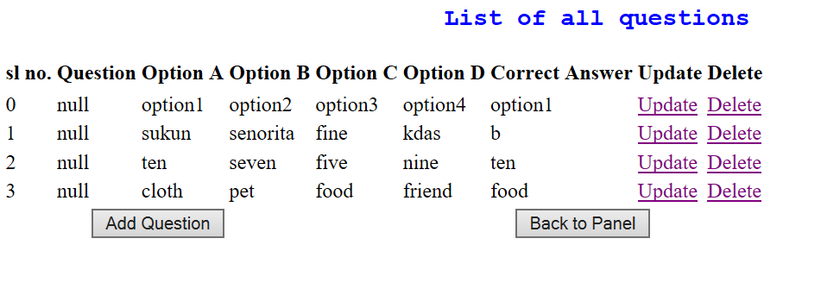

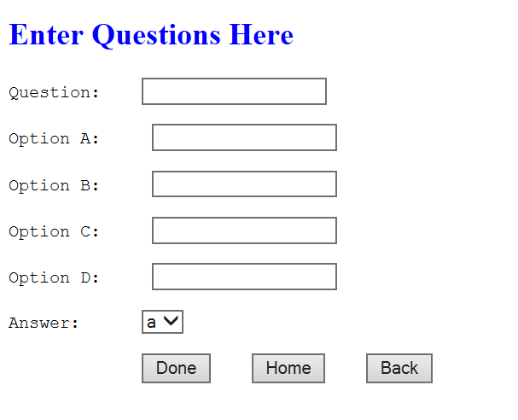

I have created a table in database for student and questions .Admin can only add the question .

In QuestionDAO and StudentDAO I have written the login for inserting deleting updating .

In QuestionInsert and AddQuestions.jsp I have written the login for inserting the question.

When I want to do Any CRUD operation I call the object and do the process.

For doing the CRUD operation I have given the access only to admin .

1. Student Login::

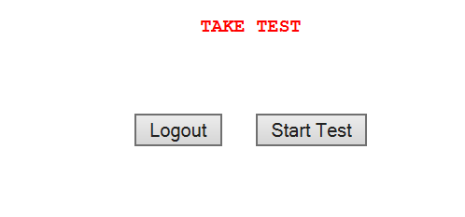

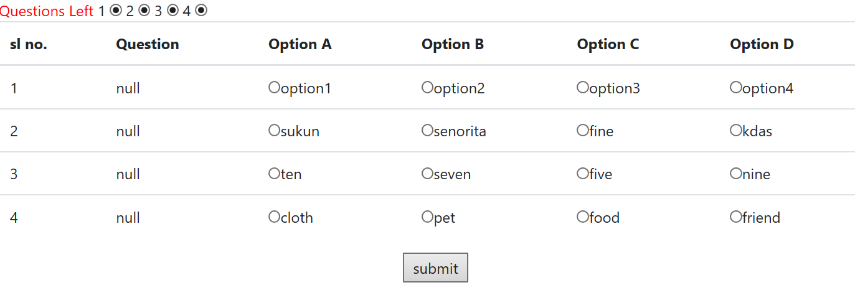

Admin have entered the questions for student exam .Student can give the exam for selecting one option I have used radio button.

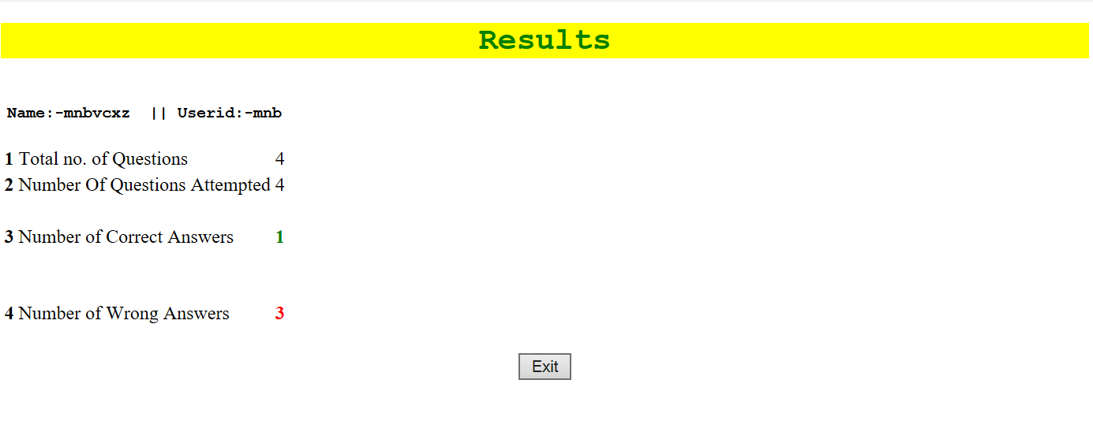

Whatever student select it will compare with the right answer which Admin has already set.Using counter the marks get incremented .If student select the right answer the count get incremented.And at the end I can see the Result .No. of Question ,No. of question Attempted,No.of correct answer and No. of wrong answer.

1. DATABASE::

